

**Module Code & Module Title**

**CS6P05NI Final Year Project**

**Assessment Weightage & Type**

**5% FYP Proposal**

**Semester**

**2024 Autumn**

**PROJECT TITLE: Smart Learning**

**Student Name: Sumit Pokhrel**

**London Met ID:22085636**

**College ID:NP01CP4S230034**

**Internal Supervisor: Saroj Yadav**

**External Supervisor: Buddha man Nepali**

**Assignment Due Date:**

**Assignment Submission Date:**

**Word Count (Where Required):**

*I confirm that I understand my coursework needs to be submitted online via Google Classroom under the relevant module page before the deadline for my assignment to be accepted and marked. I am fully aware that late submissions will be treated as non-submission and a mark of zero will be awarded*

**Table of Contents**

1. Introduction: 2

1.1 Problem Scenario: 3

1.2 Project as Solution: 3

2. Aims and Objectives: 4

2.1 Aims: 4

2.2 Objectives: 4

3. Expected Outcomes and Deliverables: 4

4. Project risks, threats and contingency plans: 6

5. Methodology: 7

5.1 Selected Methodology 7

5.1.1 Rational Unified process (RUP) 7

6. Resource Requirements: 9

7. Work breakdown structure: 10

8.Milestone Chart 11

9. Project Gantt Chart 12

10. Conclusion 13

11 .References 14

**Table of Figures**

Figure 1:Work breakdown structure 11

Figure 2:Milesstone Chart 12

Figure 3:Gantt chart 13

# 

# 1. Introduction:

In the quickly changing world of today, technology has emerged as an essential part of daily life. While it has mostly been defined in terms of "heavy machines" and "super inventions," technology is much more than that; at its most fundamental level, it is the combination of different working techniques, Technology, which ranges from the most basic instruments to the most complex machinery, has surely advanced constantly over time, changing how people interact and work while also enhancing quality of life. (Shammah, 2023)

Everybody's life is greatly influenced by their education. It promotes the growth of intelligence, character, and worldview. Each of us will have our own opinions and ways of doing things, regardless of our educational background, but careful study planning is essential. It is a carefully organized curriculum that includes study schedules and learning goals. help you oversee your college experience and hold you responsible for your individual learning goals. Still, in order to organize their study time, a lot of students use paper planners or handwrite their schedules. In order to help students with their work in all areas of learning, I therefore had the idea to create online applications (**Smart Learning**).

## Problem Scenario:

Many students still have trouble managing their time effectively and dealing with study-related problems during their academic careers, especially in light of the growing digital nature of the world. Below is a list of the majority of issues that students encounter:

* While working on projects and coursework, students waste time looking up resources such as PDFs, old notes, and relevant references.
* It is impossible for students to keep track of or record their academic progress, whether it is increasing or decreasing from previous results.
* Between the constant workload and assignments, students frequently forget the deadline, can't manage their time, and rush through the last hour of work.

## Project as Solution:

Every problem listed above has a direct solution in this project. Students won't have to spend time looking for notes and rushing through their schoolwork in the final hour. Following are the Solution of the problem faced by students during their academic career:

* Students can add images and PDF files that relate to the subject and organize them into a category.
* Students can monitor their success on a daily, weekly, or monthly basis and update their work and tasks completed in less than a day.
* Students may activate reminders for any important dates and make changes to their coursework, assignments, and class schedule.

# 2. Aims and Objectives:

## 2.1 Aims:

This project's main objective is to create a user-friendly, practical, dependable web-based learning system where users can sign up and verify their credentials to use the app, thereby removing the difficulties that manual study planning and time management cause students to face in their academic careers and chat to another student.

## 2.2 Objectives:

* To build a web application that has every feature available.
* To perform a comprehensive and in-depth analysis of the tools and related subjects that will be utilized in the app.
* To give Student a simple method of time management by organizing all of their notes, photos, and PDFs.
* To organize their task checklist.
* To give student an easy-to-use means of tracking performance.
* To give student an easy way of communication to the other student.

# 3. Expected Outcomes and Deliverables:

During the completion of this project, students will be able to effectively organize their time for college work by using the web-based application Smart Learning, which will also allow them to centrally store study materials. Once this project has been constructed successfully, it will carry out the following Outcomes:

* Show the user's login page so they may access the system.
* Upload documents in PDF format, notes, and photos based on the user's categories.
* To receive a reminder of any important work, like as an assignment, CW, or significant event.
* Save the teacher's contact information, such as their email address.
* calendar to make it simple to create a reminder.
* To monitor a student's progress, review the list of tasks to see if they have been completed successfully.
* A student performance tracker allows you to monitor their daily, weekly, or monthly performance and all of the work and tasks they completed in a 24-hour period.
* Student can share documents in PDF format, notes, and photos to the user of smart learning
* Chat can be done between one student to another student.

Deliverables:

* Functional Prototype

A Smart learning functional prototype showing the following features:

* User Access login
* Document Management
* Reminders
* Teacher Contact Management
* Task Monitoring
* Collaboration
* Performance Tracking
* Calendar Integration
* Documentation:
* System Design details
* User guides
* Instruction of deployment

# 4. Project risks, threats and contingency plans:

Projects don't always go as planned. Project risks are the particular circumstances that are specific to each project and might limit its completion. The technique of controlling risk is known as risk management. This involves changing an activity's characteristics in order to reduce the probability and severity of a risk occurring. Contingency planning is essential for risk management, catastrophe recovery, and business continuity. Here are a few dangers that I may encounter while completing the project:

|  |  |  |  |
| --- | --- | --- | --- |
| **S. N** | **Risk and Threats** | **Probability** | **Contingency** |
| **1** | During the development phase, software may crash. | Low | secure backup of the data and code for the project. |
| **2** | Debugging the code may be difficult | Medium | identifying mistakes in the programs and debugging them using the exclusive websites. |
| **3** | Poor security might severely interfere with the system | Medium | The effective functioning of the system depends on physical security. |
| **4** | Poor Internet Connection | Medium | A mobile data hotspot or other backup plan must to be accessible. |
| **5** | Problem in implementation of the database. | Medium | Proper research should be done on different websites. |
| **6** | It might not meet every necessary required to construct the application. | Low | while creating the application, make sure that every requirement is fulfilled. |

# 5. Methodology:

The Software Development Life Cycle is a structured process for designing, developing, and testing quality software. The Software Development Life Cycle is a methodology that clearly outlines the software development process. The objective of the SDLC life cycle model is to produce and deliver quality, maintainable software that meets the user's requirements. Software Development Life Cycle is a plan applicable in the software engineering models. (geeksforgeeks, 2024)

## 5.1 Selected Methodology

### 5.1.1 Rational Unified process (RUP)

The object-oriented model software development approach is known as Rational Unified approach, or RUP. It is also referred to as the Unified Process Model. In its design and documentation, UML, or Unified Modeling Language, is utilized, and it was developed by Rational Corporation. RUP reduces unplanned development costs and prevents wastages of resources. (geeksforgeeks, 2024)

The Rational Unified Process (RUP) divides the development process into four differences

phases, each of which includes business modeling, analysis and design,

implementation, testing, and deployment. The four stages are as follows:

1. Inception:

It is the initial phase of growth. We basically decide on the project's design and fundamental idea at this point. Its main objectives are to analyze project demands and estimate the resources needed to meet those goals. The following is a summary of the stages that comprise the initial phases of my project:

* Evaluate the project and talk with the supervisor about the documentation and development processes.
* Finalizing the idea for the project.
* Determination of the initial requirements.
* Risk assessment of the project.
* Time and cost estimation for project.

1. Elaboration:

In the elaboration stage, the project concept and required resources are looked into in detail. In this phase, the project plan is defined, the needs and design of the system are examined, and the riskiest aspects of the project are mitigated. It is without a doubt the most crucial stage since it signifies the change in risk from low to high. Additionally, this is the time when we have to choose whether or not to begin coding and constructing development. The actions include the following is a list of my project's elaboration phases:

* Research of the resource’s requirement of project
* creation of Architecture diagrams, such as ER diagrams, class diagrams, Gantt chart, work break down etc.
* Preparing of proposal

1. Construction:

In the development process, this is the third phase. Now that every feature and component has been developed, the project is prepared to incorporate them into the final product. The project's main development occurs in this stage, as the name suggests. The product of this work ought to be prepared for usage and deployment at the intended site. The product must be tested, documented, and coded. The phases include the following is a schedule of the construction phases of my project:

* Application Building.
* Preparing of project
* Testing

1. Transaction:

The objective of the transition phase is to transfer the product to its new user.   
Almost always, issues that need for system modifications appear as soon as the user starts utilizing the system. However, the user's smooth and positive transition is the main goal. This requires not just completing certain previously postponed features but also overseeing all bug fixes and issue resolutions. It is the procedure for development. The stages that make up the Transaction phases for my project are stated as follows:

* Final App release
* Performance Tracking
* Defect Fixing

# 6. Resource Requirements:

6.1 Hardware Requirement

* Laptop or Desktop
* Ram:8GB RAM

6.2 Software Requirements

* Front end: React/Js
* Backend: Node.js
* Database: MySQL
* Text Editor: Visual Studio Code
* Draw.io for creating various diagram.
* Prototyping: Figma.
* Microsoft Word for documentation
* Version Control: GitHub

# 7. Work breakdown structure:

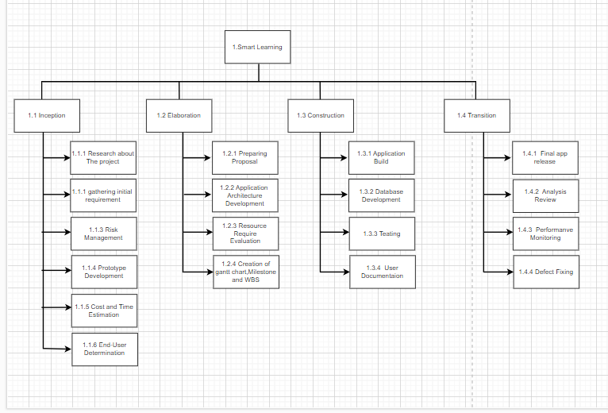

Figure :Work breakdown structure

# 8.Milestone Chart

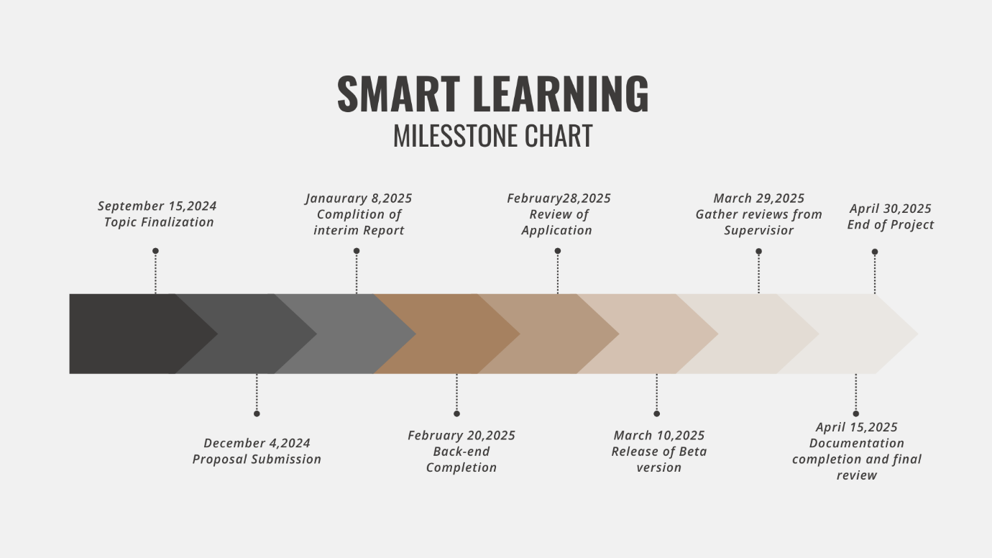

# 9. Project Gantt Chart

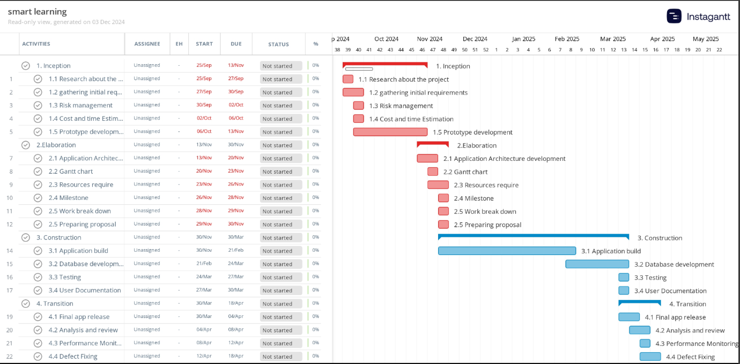A Gantt chart is a project management tool that helps with scheduling and planning projects of all kinds. It is especially helpful for visualizing projects. Project managers use a Gantt chart, which is a graphical depiction of activities versus time, to track advancement. (apm, 2025)

Figure :Gantt chart

# 10. Conclusion

Smart Learning is designed to meet essential requirements of student, makes making their lives easier by providing a one-stop solution for event planning and progress tracking.I will put my best effort and dedication into this project, conducting thorough research I get to learn various Framework, Api, Architecture and so on. From this project I will get experience and knowledge which will be valuable for the future.

# 11. References

apm, 2025. *What is a Gantt chart?.* [Online]   
Available at: https://www.apm.org.uk/resources/find-a-resource/gantt-chart/

geeksforgeeks, 2024. *Software Development Life Cycle (SDLC).* [Online]   
Available at: https://www.geeksforgeeks.org/software-development-life-cycle-sdlc/

geeksforgeeks, 2024. *What is RUP(Rational Unified Process) and its Phases?.* [Online]   
Available at: https://www.geeksforgeeks.org/rup-and-its-phases/

Shammah, N., 2023. What Is Technology? Meaning, Types And Impacts Explained. *icoverage.io,* 23 July.